Coach Sifford’s
World History Projects

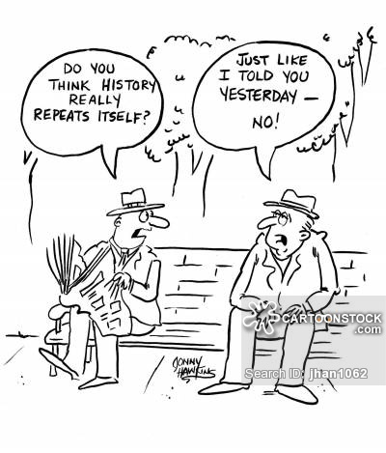

Name _________________

First Assignment is to pick one from the following:

I. Three Forms of Historical Writing
Historical interpretations can be presented in three different forms that correspond to the basic forms of historical writing:
1. Argument: An argumentative essay presents the interpretation in the form of a thesis and reasons for that thesis.

2. Narrative: A narrative essay presents the interpretation in the form of a narrative or story.

3. Description: Descriptive essay gives a portrayal of a person, place or object at a particular moment in time.

A. Communism vs. Socialism 1850-1904
B. Age of Imperialism 1850-1904
C. Age of Democracy 1850-1904
D. Transformations Around the Globe 1850-1904

Essays should include the following:
1. 3 - 5 page typed double-or 5-7 pages handwritten.
2. Include quotes and historical references
3. Works cited page and include footnotes of quotes.

Second Assignment
Modern World History Unit III Project: 19th Century Time Capsule
Assigned: 1/26 Final Project Due: 2/9
Objective: Create a time capsule with artifacts in it that relate to the 19th Century themes of Nationalism, Industrialization, and Imperialism. This project will be worth 100 points.
Time Capsule: Create a time capsule. (A shoe box, or a similar sized box, would work well.) Decorate the time capsule creatively and appropriately. One idea would be to draw pictures or print out photographs and images from the 19th century.
Artifacts: Create historical items that go inside the time capsule.
- A diary entry that explains what life was like during the age of Imperialism. Your diary entry will be written from a specific perspective. (Examples: British imperialist, European missionary, African native, participant in the Boxer Rebellion, etc.)
Each diary entry should include:
- facts from the Age of Imperialism
2-3 paragraphs - Be in a diary format (Dear Diary….) Hand-written or typed
Have a date and location (ex: March 1, 1880, India)
- 1 newspaper article—Create a brief newspaper article with a headline about one significant event that occurred during the 19th century about Nationalism. (Examples: Italian unification, the rise of Otto Von Bismarck, the Franco-Prussian War, etc.)
- Headline
- 2-3 paragraphs about the event
- 1 quote (real or made-up, but still historically accurate (Example: Otto von Bismarck stated, “…..”)

- 1 invention brochure---Create a brochure advertising a new invention from the Industrial Revolution. (20 points)
Cover: Name of invention
- Photograph or image of the invention
- Year it was invented and name of inventor
Inside:
- Purpose of the invention (What did it do?)
- What industry will it be used in? (examples: agriculture, mining, textiles, transportation)
- Who will benefit from the invention?
- Why is this invention important?

- 2 physical items associated with Industrialization, Nationalism or Imperialism. You can choose any combination you want. These must be historically relevant items. Each item should have a 1-3 sentences explanation. (Examples: photograph, artwork, a political cartoon, a poem, a song, map, flag, compass, raw material, object, etc.)

THIS IS AN INDEPENDENT PROJECT! MAKE SOMETHING YOU CAN BE PROUD OF!
Step 1: Time Capsule
- Explain how you are going to decorate it:

Step 2: Artifacts

Imperialism Diary Entry

  - Whose view point will you be writing from? ________________

  - List the 3 facts you will include:

1.
2.
3.

Nationalism Newspaper Article

- What event will you be writing about?

- What is your headline going to be?

Industrial Revolution Invention Brochure

- What invention?______________

- Who is the inventor? _____________

- Year it was invented: ____________

- Do you have a photograph or image? _________

- What is the purpose of the invention?_______________

- What industry is it used in? _____________

- Who will benefit from the invention?__________________

- Why is this invention important? ____________________________________

Physical Items
- Item #1: _____________

- Item #2: _____________

Choose TWO from the following for Chapters 9-12:
1. Timeline of 6 events from each chapter with pictures and explanations (5-7 sent).
2. A-Z picture collage with detailed explanations of each (5-7 sent) with at least 6 letters from each chapter.
3. Create a magazine with a central theme (ie…industrial revolution, imperialism, Darwin’s Theory of Evolution etc…) include pictures (at least one hand drawn) news article and commentary on theme (perspective).
4. 32 word crossword puzzle with at least 8 words from each chapter (with answer key).
5. Biographies: write the life story of someone else. It has to be a historical figure. The biography has to be 2 pages with accomplishments, impact etc… Cite sources
6. Board games: create a board game where students could review course concepts. Game play should be based around answering review questions correctly.
7. Brochures: brochures can be made as either tri-fold or bi-folds. You can create informational brochures about geographic locations, a story’s setting, or a historical event such as how the industrial revolution evolved around the world.
8. Calendars: create a calendar charting the dates of key events. This can be applied to an historical event (like a famous battle).
9. Coat of Arms: create a family coat of arms for a character from a person in history. Use their impact on history to design your own. Each symbol must be explained.
10. Comic Strips or Books: create an illustrated comic strip or book representing events from history and a detailed explanation.
11. Flags: create a flag representing either an actual county. The project should be accompanied by a brief report explaining what ideas the colors and images on the flags represent.
12. Hieroglyphics: create pictures that represent vocabulary words. Alternately, students could retell the events of a story or historical episode in simple pictures. (at least 10)
13. Illustrated Quotes: You should choose meaningful quotes (3 from each chapter). You should explain why the quote interests you and then write the quote on a blank sheet of paper and draw related images.
14. Yearbook: create a yearbook reviewing 20 people and or events containing information about many important figures from history.

